Project Design Phase-II
Technology Stack (Architecture & Stack)

Date | 6 July 2026
Team ID
Project Name | Online Complaint Registration System
Maximum Marks | 4 Marks

Technical Architecture:
The Online Complaint Registration System follows a three-tier MERN stack architecture. The application consists of a React.js frontend, Node.js and Express.js backend server, and MongoDB database.
Users interact with the React web application to submit and track complaints. The frontend communicates with backend REST APIs. The backend processes user requests, manages authentication, handles complaint operations, and stores data securely in MongoDB.

Example: Online Complaint Registration System using MERN Stack
Reference:
https://www.mongodb.com/mern-stack
Architecture Description:
The Online Complaint Registration System follows a MERN stack based three-tier architecture. The system provides an online platform where users can register complaints, agents can handle assigned complaints, and administrators can manage the overall complaint resolution process.
The user interacts with the application through the React.js web interface. The frontend sends requests to the backend server through REST APIs. The backend is developed using Node.js and Express.js, which handles authentication, complaint processing, user management, and business logic.
MongoDB Atlas is used as the cloud database for storing user details, complaint information, agent details, and complaint status history. The system uses role-based access control to provide different permissions for Users, Agents, and Administrators.
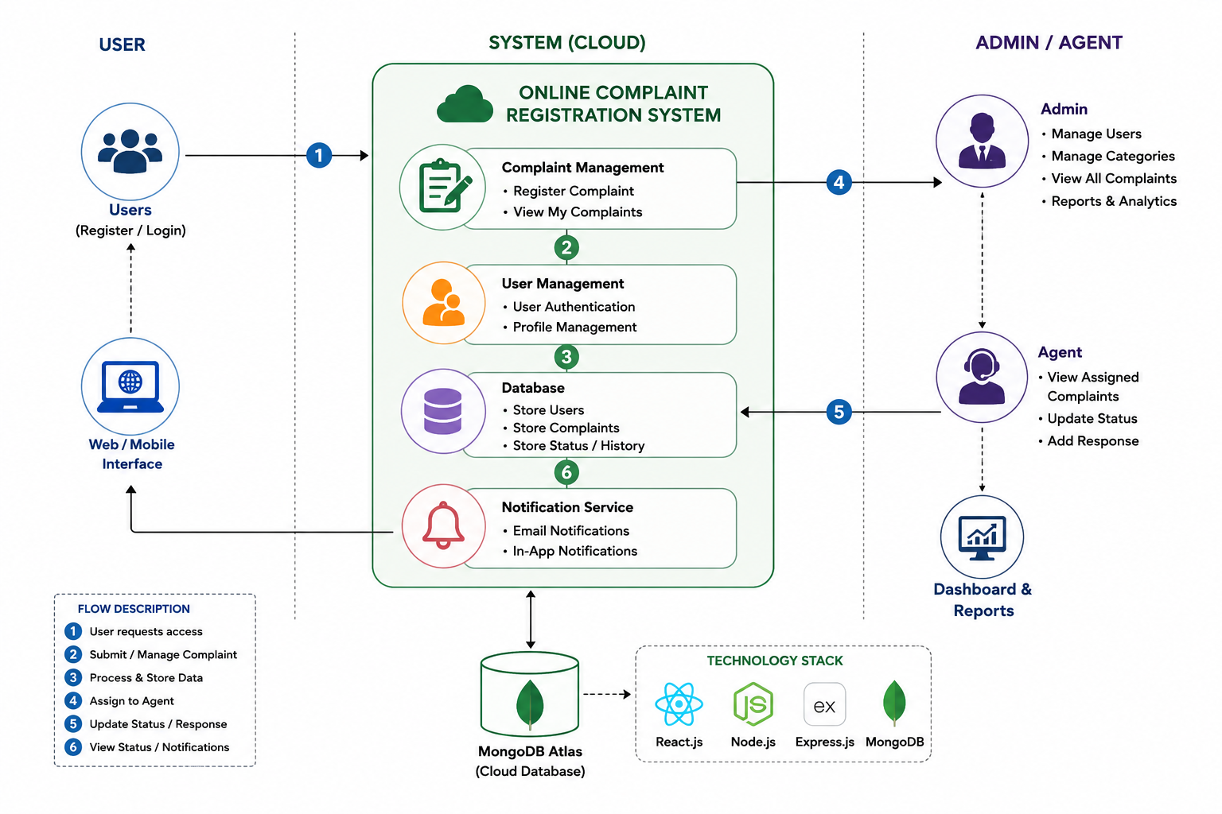

Table-1 : Components & Technologies:
S.No | Component | Description | Technology
 | User Interface | Interface where users, agents, and admins interact with the system | React.js, HTML5, CSS3, JavaScript
 | Application Logic-1 | Handles user authentication and authorization | Node.js, Express.js, JWT
 | Application Logic-2 | Handles complaint registration, assignment, and status updates | Node.js, Express.js REST APIs
 | Application Logic-3 | Handles admin and agent management operations | Express Controllers
 | Database | Stores user details, agent details, and complaint records | MongoDB
 | Cloud Database | Database hosted on cloud platform | MongoDB Atlas
 | File Storage | Stores application files and resources | Local Storage / Server Storage
 | External API-1 | Communication between frontend and backend | REST API
 | External API-2 | HTTP requests from client application | Axios
 | Machine Learning Model | Not implemented in current version | N/A
 | Infrastructure (Server / Cloud) | Application deployment and hosting | Vercel, Render

Table-2: Application Characteristics:
S.No | Characteristics | Description | Technology
 | Open-Source Frameworks | Open-source technologies used for application development | React.js, Node.js, Express.js
 | Security Implementations | Provides secure authentication and protected access | JWT Authentication, Password Encryption
 | Scalable Architecture | Application can handle multiple users and future enhancements | MERN Three-Tier Architecture
 | Availability | Application is hosted online and accessible through browser | Vercel Deployment
 | Performance | Fast response time through optimized frontend and backend communication | React Components, REST APIs, MongoDB

References:
https://react.dev/
https://nodejs.org/en/docs/
https://expressjs.com/
https://www.mongodb.com/docs/
https://www.mongodb.com/mern-stack
https://vercel.com/docs

